LA wildfires support & resources
Title | Support for LA wildfire victims
ID | BA_LAfires_1.0
Short description | Resources and relief from Meta benefit providers.
Group tag (0 – 1)
Topic tags (1 – 2)
Push | Help for LA wildfire victims 🌟  Whether you need support or want to help, find resources for those affected by the LA wildfires. Together, we can make a difference! 💖 Read more now.

Cover
[Label: 30 characters max]
META BENEFITS
[Title: 48 characters max]
Support for LA wildfire victims
[Description: 207 characters max]
If you’re affected by or concerned about the recent wildfires in Los Angeles, Meta benefit providers are ready to help. Review your options for recovery and support, from finances to housing and health.
[CTA: Start reading ]
Start reading
[Design direction:]
A supportive community of helpers.


Context plain
[Title: 45 characters goal, 80 max]
Look for the helpers
[Paragraph 1: 147 characters goal, 500 max]
We know that the wildfires in Los Angeles have affected many of you, bringing loss, uncertainty, and displacement. Others not in LA are feeling deep empathy.
[Paragraph 2: 147 characters goal, 500 max]
As Mr. Rogers once said about distressful current events, “Look for the helpers. You will always find people who are helping.” Life@ resources can help you navigate this challenging time together.
[Tip header (optional): 50 characters max]
Take time off if you need it.
[Tip content (optional): 190 characters goal, 500 max]
From emergency PTO to sick time and unpaid leave, Meta has options to give you the time you need to find help, recover and rebuild what’s been lost.
[Design direction:]
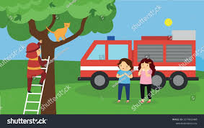
A kid watching a fireman help a cat down from a tree.

Context cards screen
[Title: 45 characters max]
Health helpers
[Paragraph 1: 145 characters goal, 500 max]
Depending on your healthcare plan, you may have access to extra services from these medical providers. Consider your needs and seek care.
[Card title: 30 characters max]
Kaiser
[Card description: 120 characters goal, 500 max]
Members have access to emergency support, from 24/7 care to an extended pharmacy network.
[Card title: 30 characters max]
Accolade
[Card description: 120 characters goal, 500 max]
Get help finding a provider or assistance with claims. (Must be enrolled in the PPO, EPO or HDHP plans.)
[Card title: 30 characters max]
Crossover
[Card description: 120 characters goal, 500 max]
Access primary, urgent, and mental health care for your physical and emotional needs—in person or online.
[Card title: 30 characters max]
Lyra
[Card description: 120 characters goal, 500 max]
Offering 24/7 support to you and your dependents, phone or online, including up to 25 free therapy sessions per year.
CVS
[Card description: 120 characters goal, 500 max]
Wildfire victims who lost their medications can get a 30-day emergency refill from CVS pharmacies.
[Design direction:]
Kaiser logo

Accolade logo

Crossover logo

Lyra logo

CVS logo


Context bullets screen
[Title: 45 characters max]
Specialty care helpers
[Paragraph 1: 145 characters goal, 500 max]
Vision, dental, and infertility services and prescriptions matter, too. Here are some ways to get extra support on those needs.
[Bullet title: 30 characters max]
VSP
[Bullet description: 120 characters goal, 500 max]
VSP members who lost or broke their eyewear due to the wildfires can contact Member Services Support for assistance.

[Bullet title: 30 characters max]
Delta Dental
[Bullet description: 120 characters goal, 500 max]
Contact customer service for your emergency dental needs. They can also find another provider if your dentist is closed due to the wildfires.
Progyny
[Bullet description: 120 characters goal, 500 max]
If you’ve had a disruption in care with your fertility treatment, Progyny is ready to help get you back on track.
[Design direction:] Firetruck, fireman or cat in tree

Context cards screen
[Title: 45 characters max]
Financial helpers
[Paragraph 1: 145 characters goal, 500 max]
Rebuilding homes and lives after the wildfires is likely to have a heavy financial toll. Get support and guidance from these providers.
[Card title: 30 characters max]
Financial Finesse
[Card description: 120 characters goal, 500 max]
Call or chat with a coach for guidance on immediate or long-term financial needs, insurance questions, and more.
[Card title: 30 characters max]
Fidelity
[Card description: 120 characters goal, 500 max]
Consider a 401(k) hardship loan or withdrawal for urgent expenses. Contact Fidelity customer service for details.
[Card title: 30 characters max]
Life@ Choice
[Card description: 120 characters goal, 500 max]
Your $2,000 wellness reimbursement can be used toward childcare, pet boarding, and more.
[Card title: 30 characters max]
Fond
[Card description: 120 characters goal, 500 max]
If you need to replace lost or damaged items, you’ll find discounts on a variety of products and services from Fond.
[Design direction:]
Financial Finesse logo

Fidelity logo

Life@ logo

Fond logo


Context bullets screen
[Title: 45 characters max]
Family helpers
[Paragraph 1: 145 characters goal, 500 max]
From housing assistance to childcare and relief programs, these providers can help families in crisis.
[Bullet title: 30 characters max]
Cleo
[Bullet description: 120 characters goal, 500 max]
A Cleo Guide can help connect you to local resources including housing, childcare centers, caretakers, and more.
[Bullet title: 30 characters max]
Bright Horizons
[Bullet description: 120 characters goal, 500 max]
Find backup childcare, access educational benefits, and get guidance on talking to kids about natural disasters.
[Bullet title: 30 characters max]
Wellthy
[Bullet description: 120 characters goal, 500 max]
Wellthy’s care coordinators can help families locate shelters, hospitals, relief programs, post-crisis assistance and more.
[Design direction:] Firetruck, fireman, cat in tree, etc.

Context cards screen
[Title: 45 characters max]
Become a helper
[Paragraph 1: 145 characters goal, 500 max]
No matter where you live, you can support victims of the LA wildfires through financial donations, donating goods, or volunteering to help.
[Card title: 30 characters max]
California Fire Foundation
[Card description: 120 characters goal, 500 max]
Donations help provide resources to active and fallen firefighters, their families, and the communities they serve.
[Card title: 30 characters max]
California Community Foundation
[Card description: 120 characters goal, 500 max]
Join CCF in supporting recovery efforts to aid those most in need by contributing to their recovery fund.
[Card title: 30 characters max]
Red Cross
[Card description: 120 characters goal, 500 max]
Help provide emergency shelters, meals, medical care, and recovery assistance with a donation.
[Card title: 30 characters max]
Canine Rescue Club
[Card description: 120 characters goal, 500 max]
Donate to support or volunteer to foster animals displaced by the wildfires.
[Card title: 30 characters max]
World Central Kitchen
[Card description: 120 characters goal, 500 max]
Help WCK provide meals to community members and first responders in the LA area.
[Design direction:]
California Fire Foundation logo
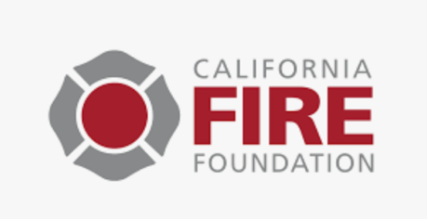
California Community Foundation logo

Red Cross logo
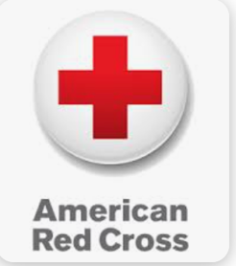
Canine Rescue Club logo
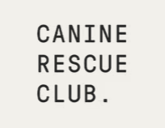
World Central Kitchen logo


Full screen image template
[Title: 45 characters goal, 80 max]
Help yourself, help others
[Paragraph 1: 160 characters goal, 500 max]
Whether you need personal help through this crisis or want to assist others, we hope you’ll take full use of these resources. Together, we can make #LAstrong.
[Design direction:]

Firefighter handing the cat to a kid, same firefighter from earlier in story


Suggestion
[Title: 45 characters max]

[Paragraph 1: 150 characters max]

[Suggestions: title/link]
- TBD
- TBD
- TBD

